Chapter 16, Problem 71.

For the ideal transformer circuit in Fig. 16.94, determine i_{o}(t).

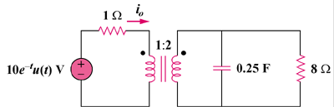

Figure 16.94
For Prob. 16.71.

